GHOSTENGINES PVT LTD INTERNSHIP ASSIGNMENT SET-3

**SET-3 MONGODB**

NAME: RAHUL PATIL

ASSIGNMENT

1. Create records similar to the sample json object given below in mongoDB.

Preparing the schema:

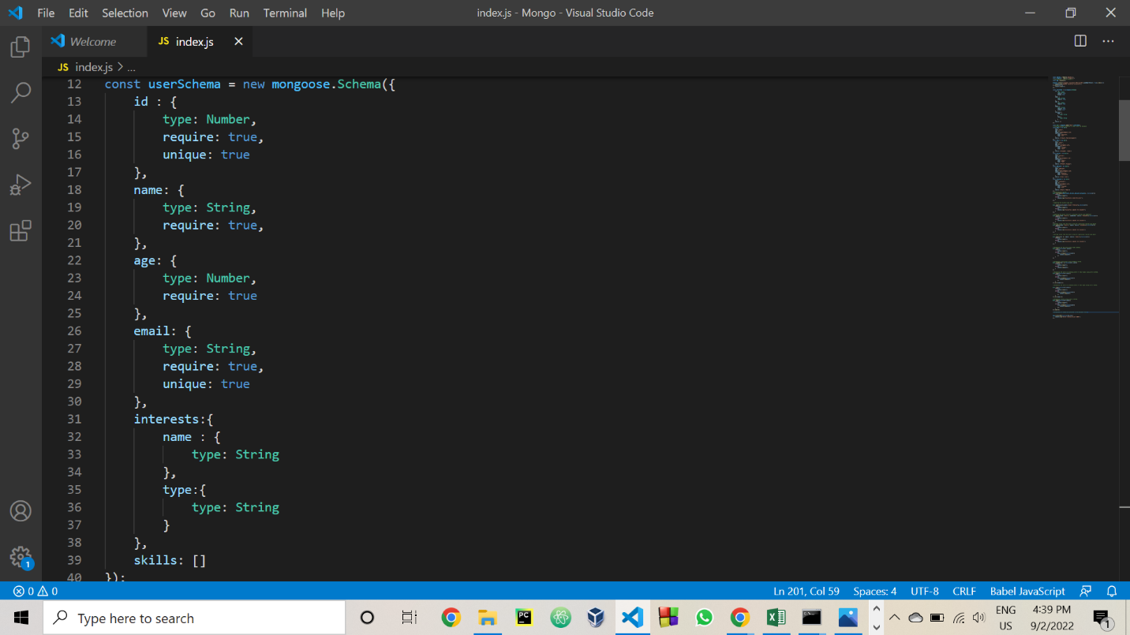

Creating 5 records manually and inserting them into Document using insertMany() function of Mongoose.

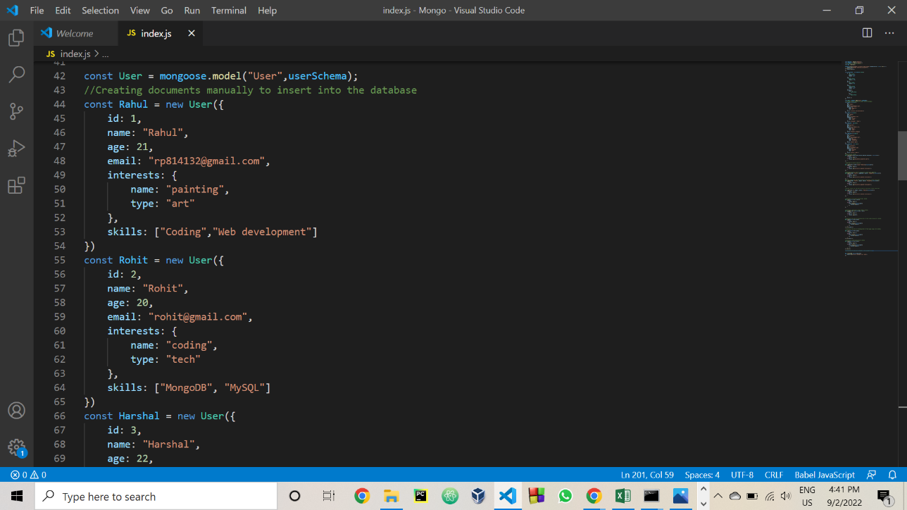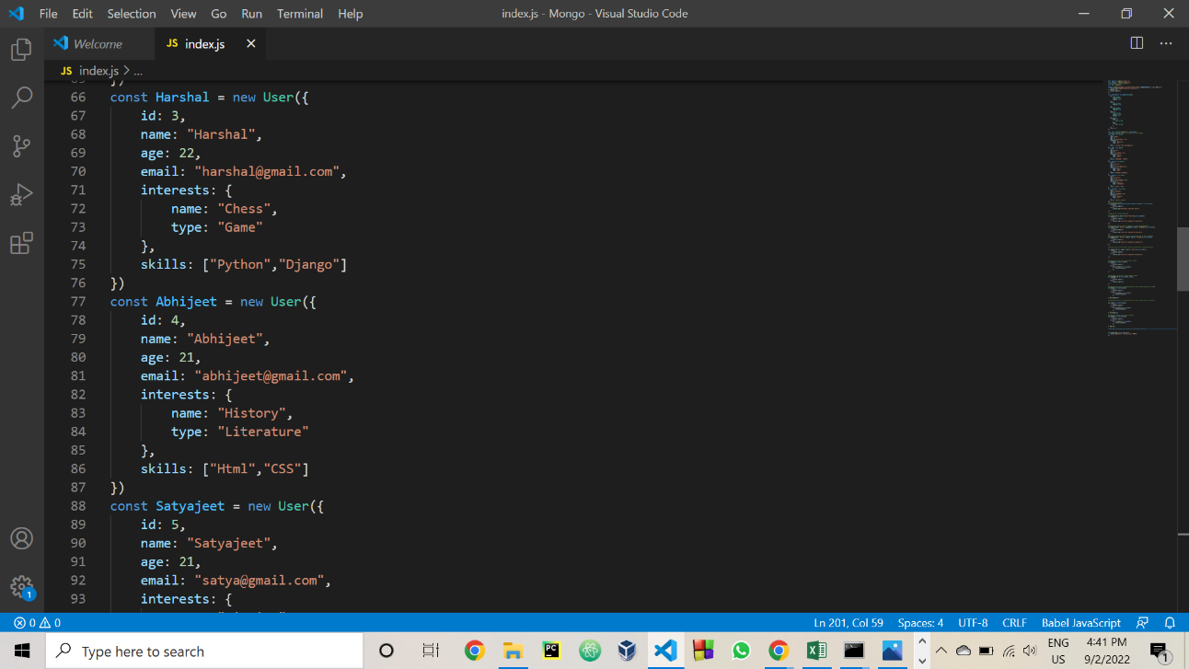

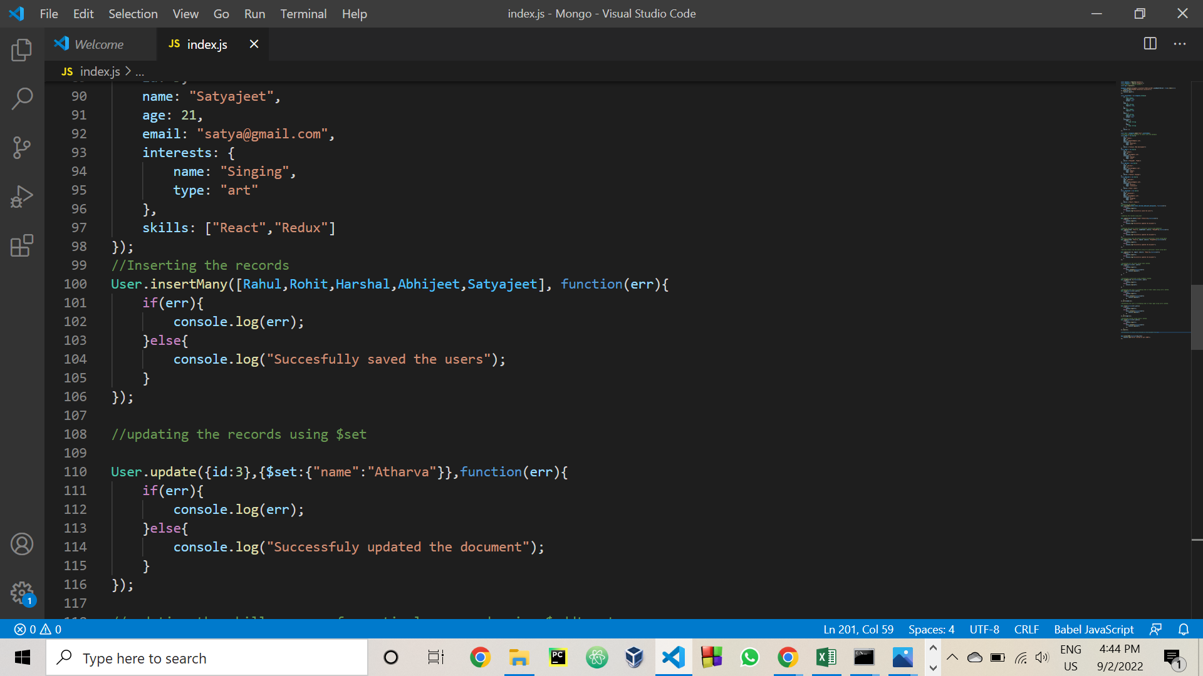

Displaying the database : OUTPUT Screenshots

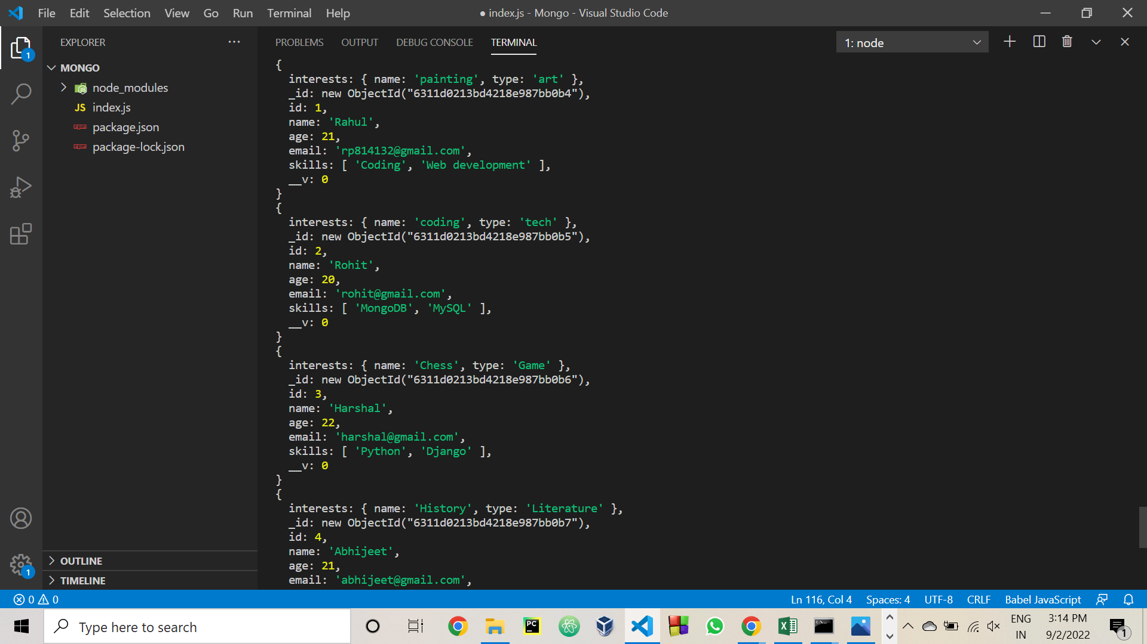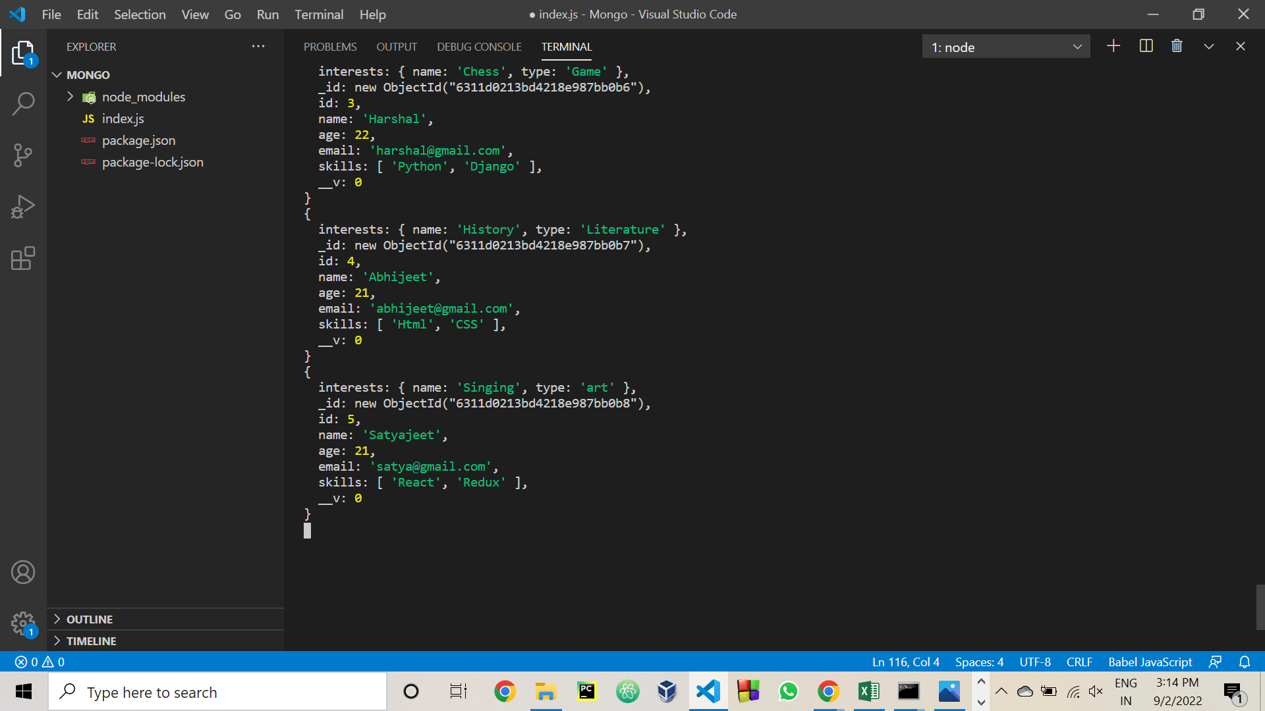

1. Update records using $set, $addtoset, $push $pull and demonstrate the difference.

* Updating records using $set

Code: Updating a record with id: 3 and setting its name to “Atharva” using $set.

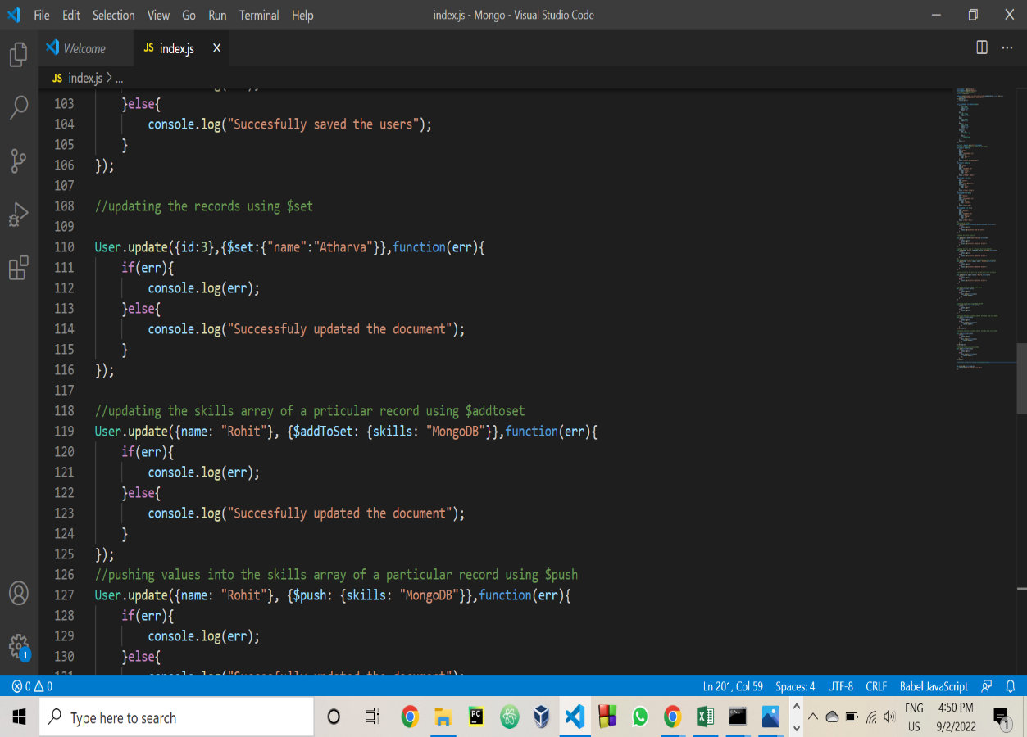

Output: Record with id: 3 is updated with a name: “Atharva”

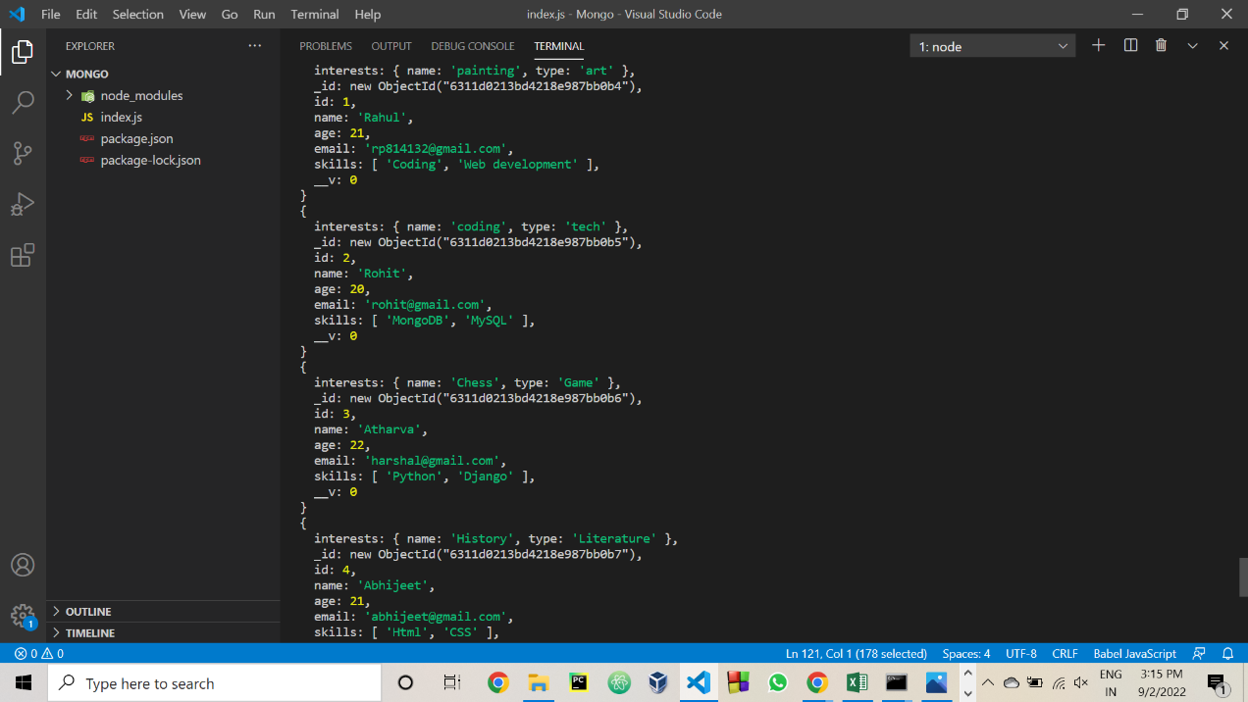

* Updating a record with $addtoset.

$addtoset: Is used to add values to the array object in a document. It does not add the duplicate values to the array.

**Code**: Adding an additional skill of “MongoDB” to the skills array of the record whose name is “Rahul”.

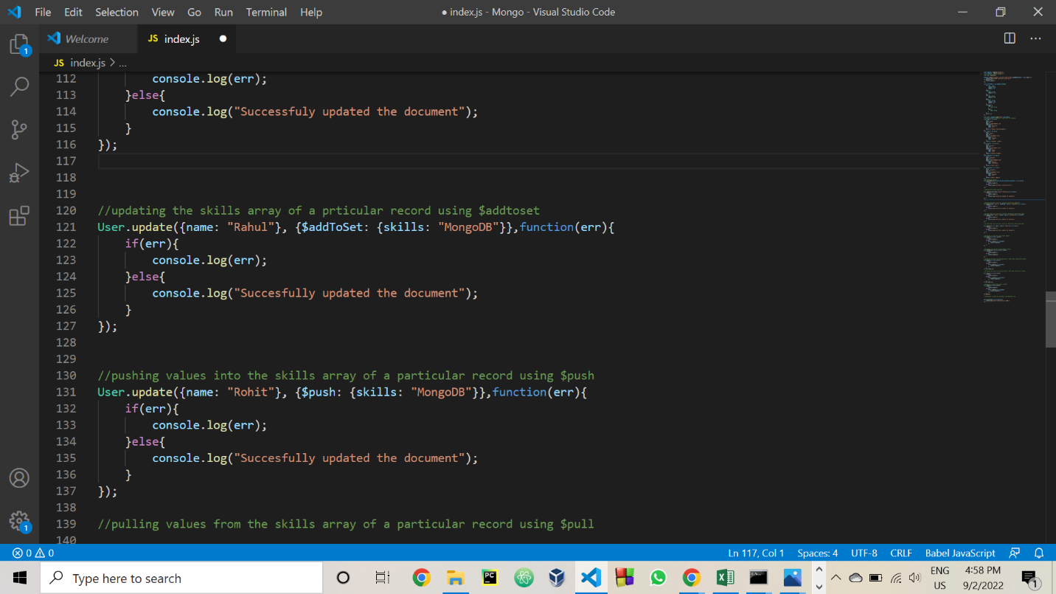

Output: You can see that one more skill “MongoDB” is added into the skills array of the record named “Rahul”.

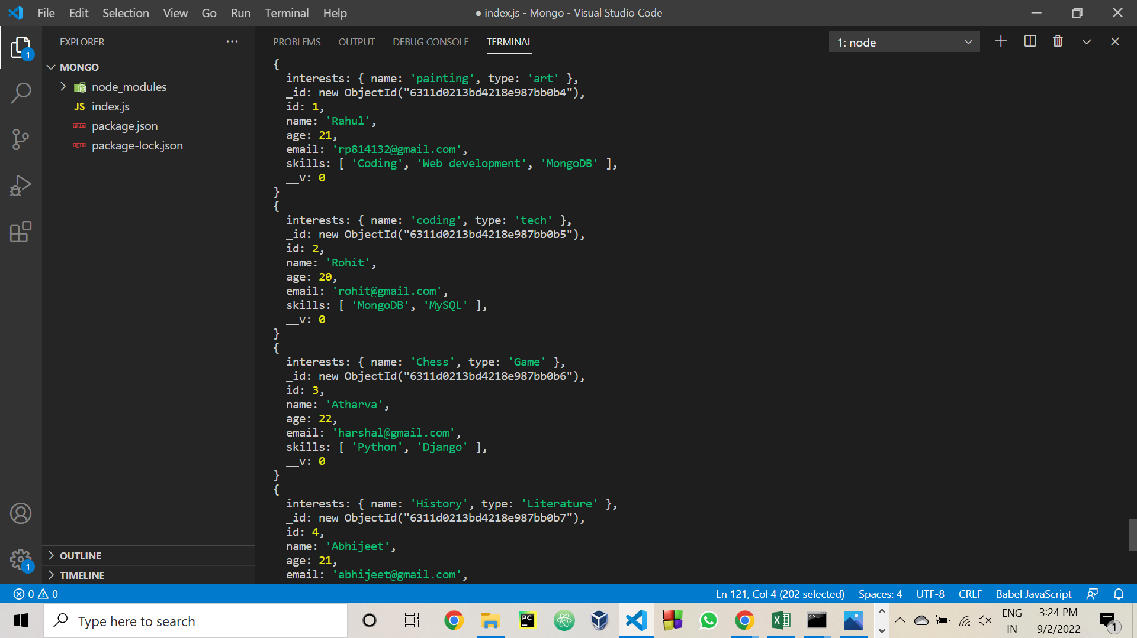

* Updating Records with $push

$push is used to add values to the array. It can also add duplicate values to the array. It is this poroperty which differs it from $addtoset as $addtoset does not add the duplicate values to the array.

Code: Here we are pushing a skill “MongoDB” into the skills array of the record named “Rohit” which already contains a skill “MongoDB”. So $push will push “MongoDB” into the array creating duplicate values.

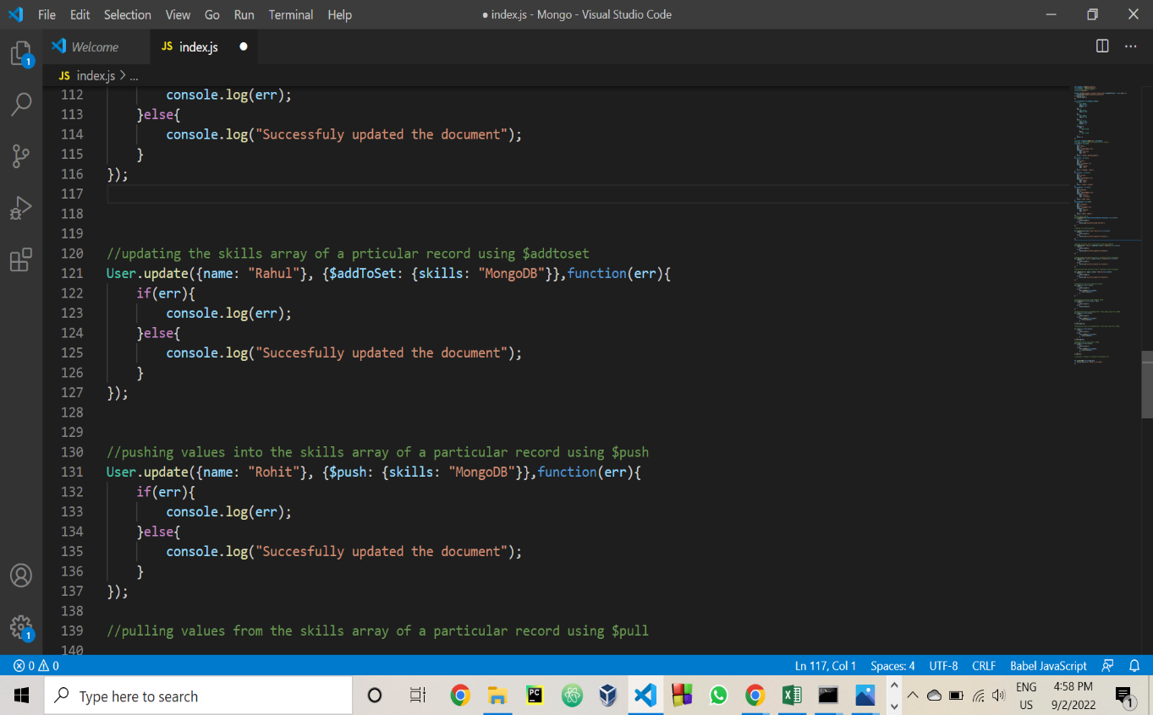

Output : Observe the skills array of record named “Rohit”. It contains two “MongoDB” values.

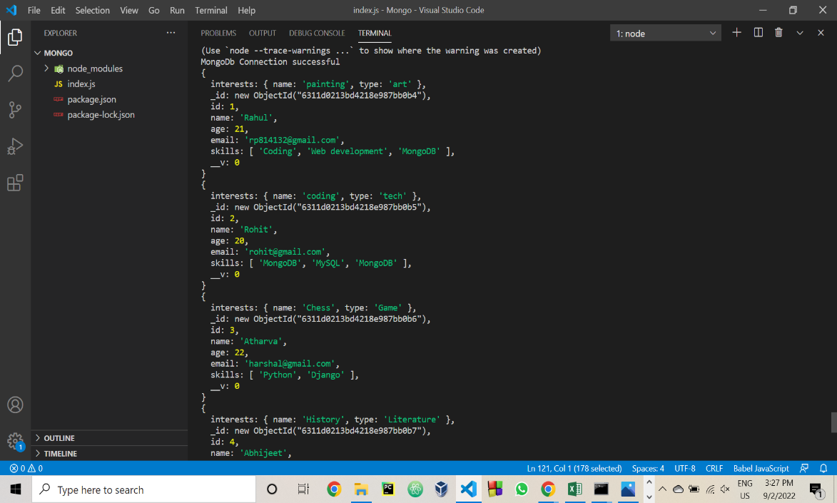

* Updating records with $pull

$pull is used to pull values from the array object.

Code: Pulling a skill “Redux” from a record with id : 5

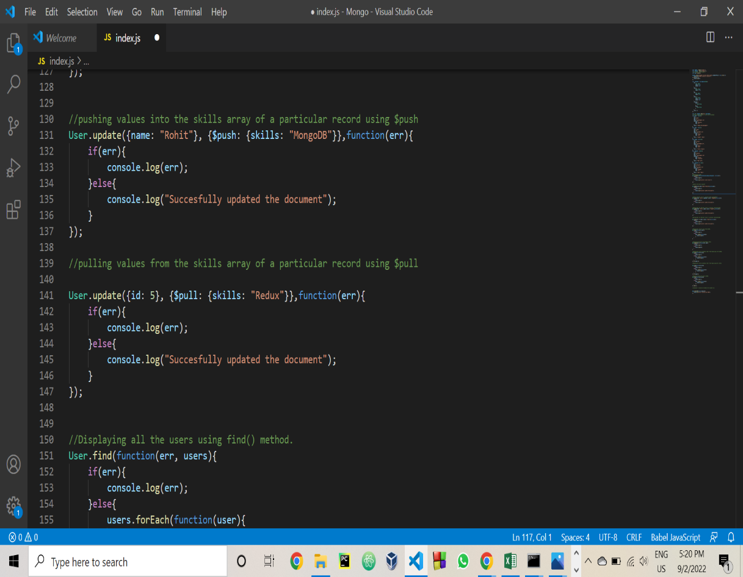

Output: Observe the skills array of the 5th record. “Redux” is removed from the array.

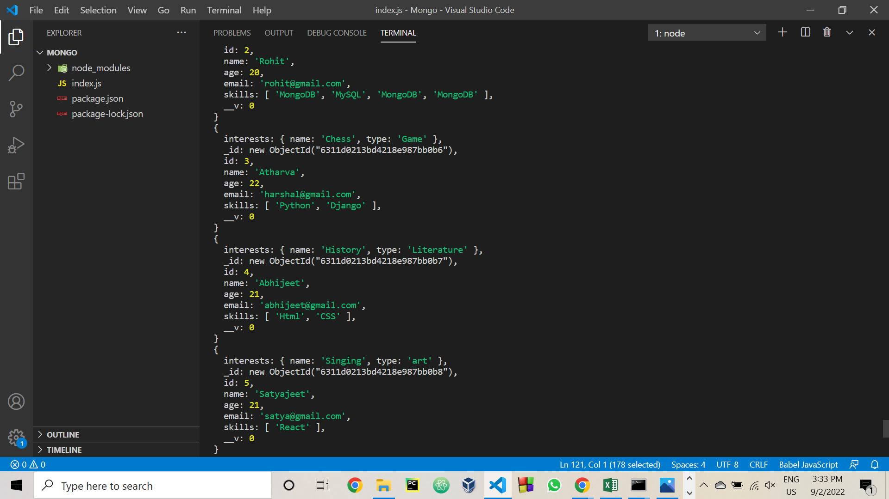

1. Query data using find, findOne, also with limits and sortBy attributes.

* Querying data using find() method.

Code:

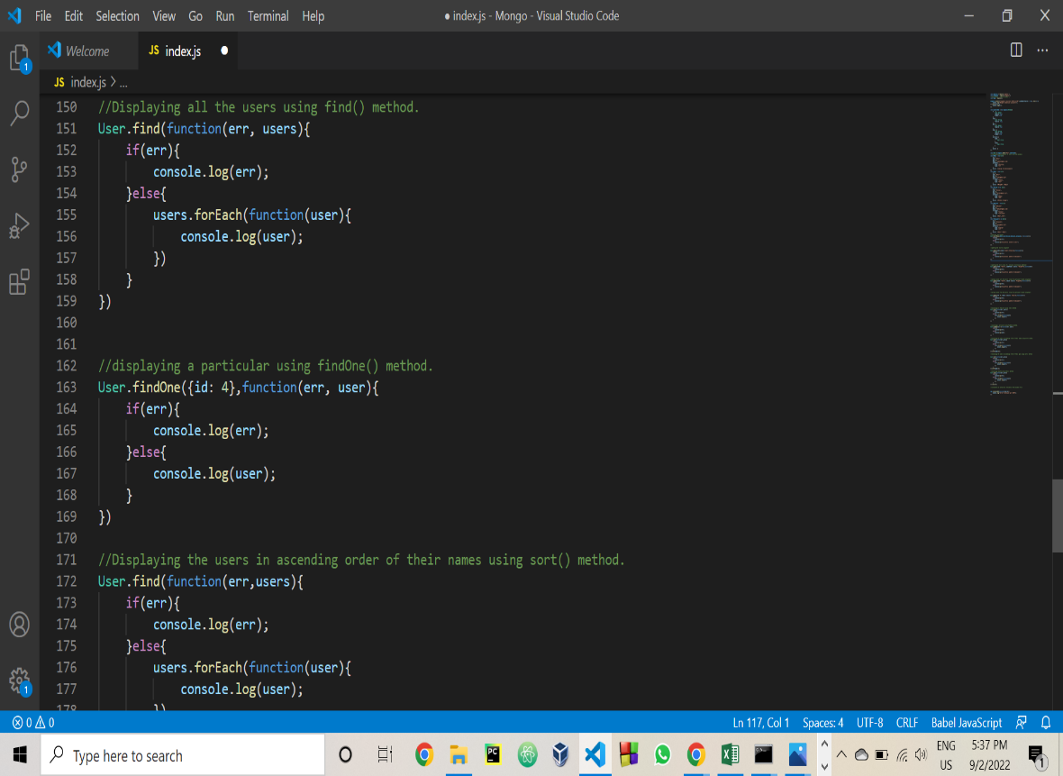

Output:



* Querying values using findOne() method.

Code: 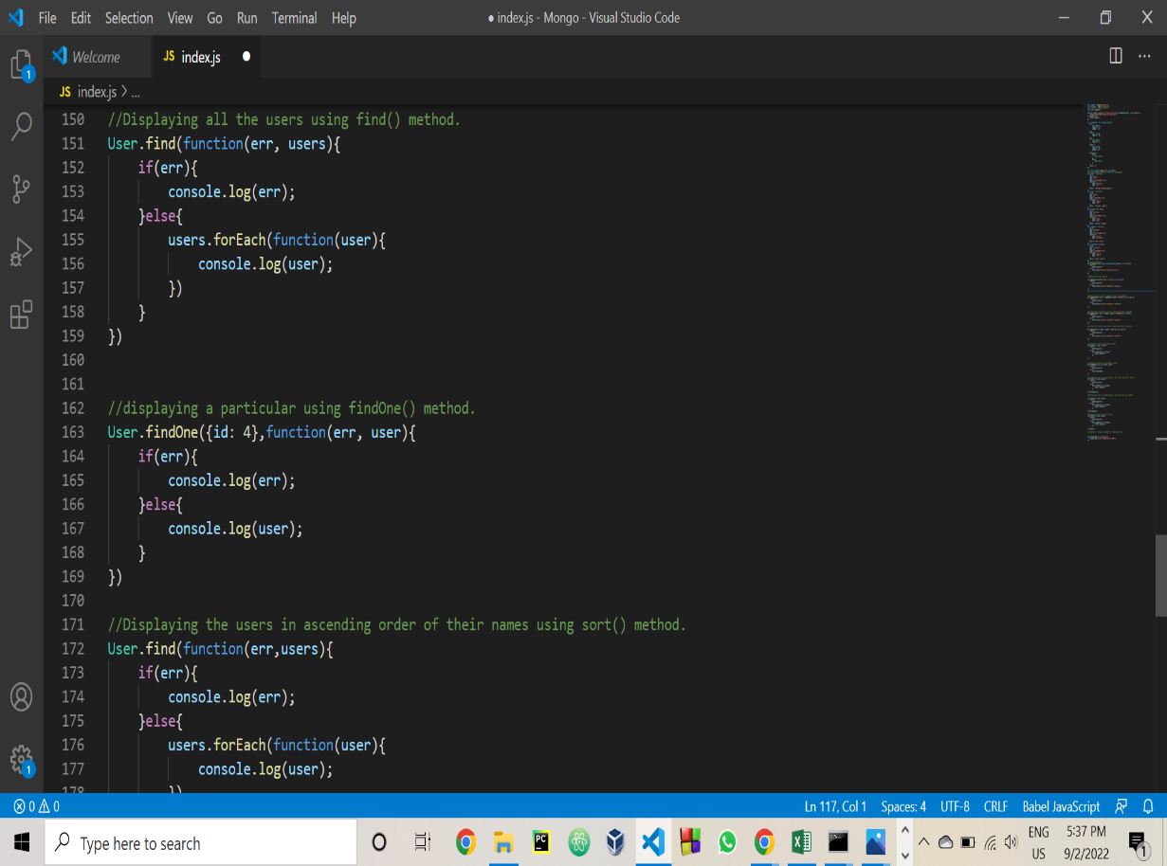

Output:

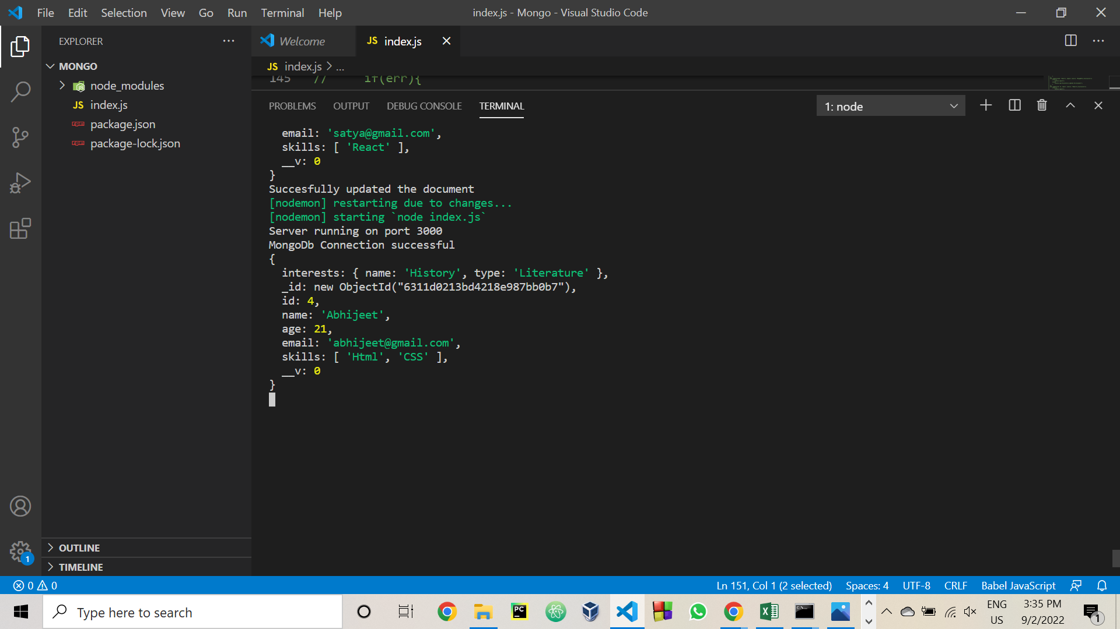

* Querying the data using find().sort() method.

Code: Sorting in the ascending order of names.

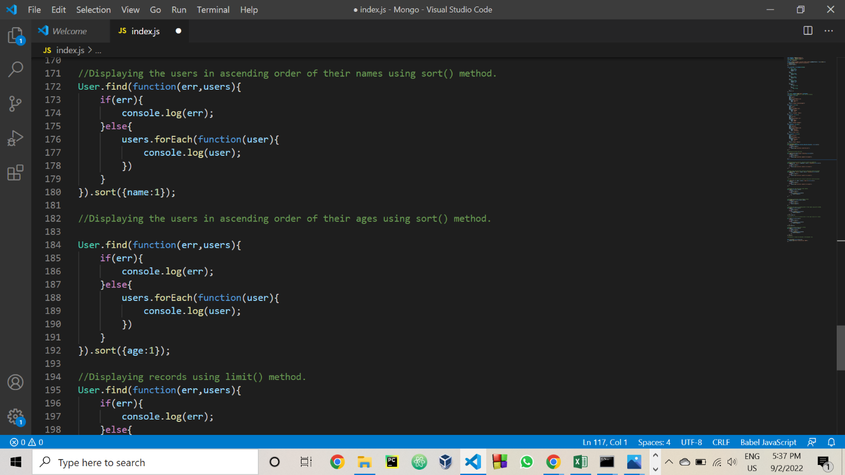

Output: Records sorted in the ascending order of names.

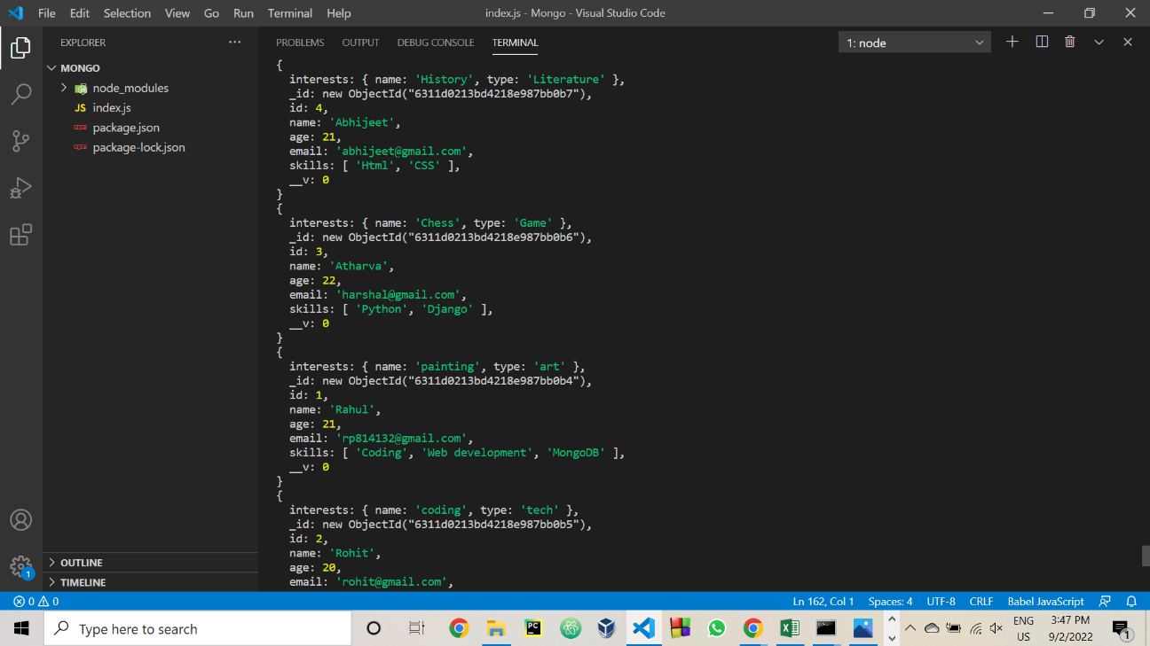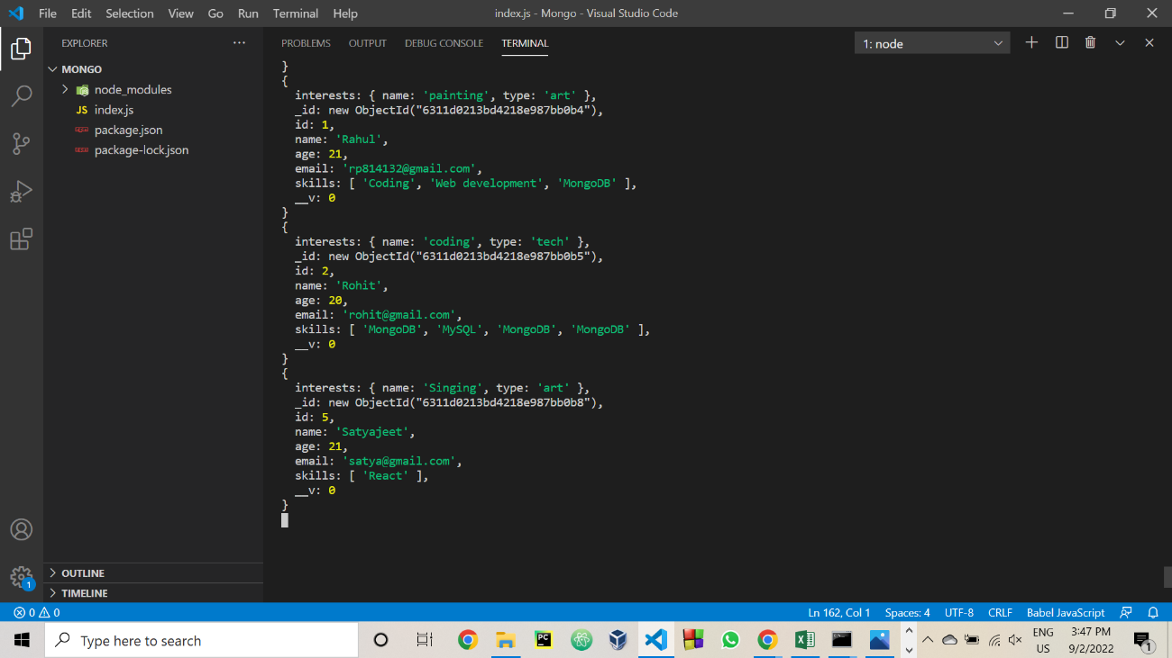

* Querying the data using limit attribute.

Code: Setting the limit to 3 records

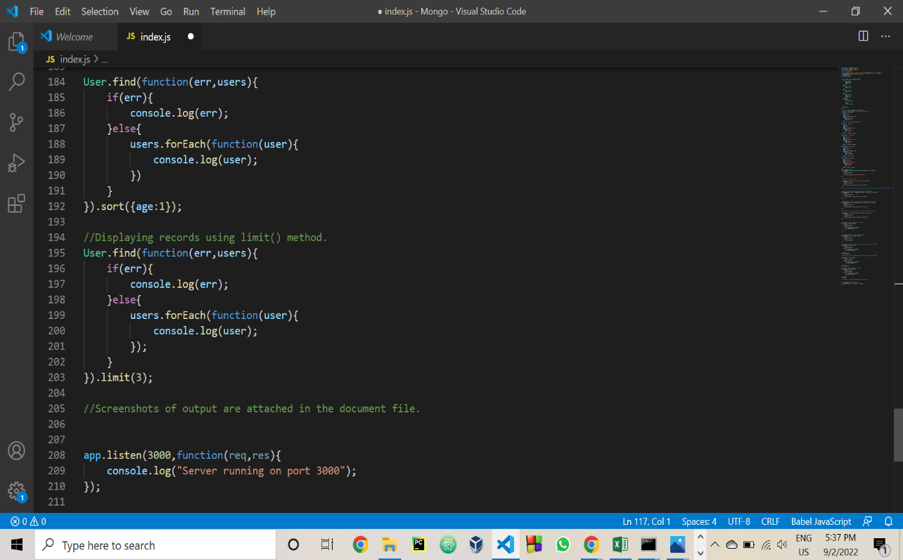

Output: Displaying only 3 records.

